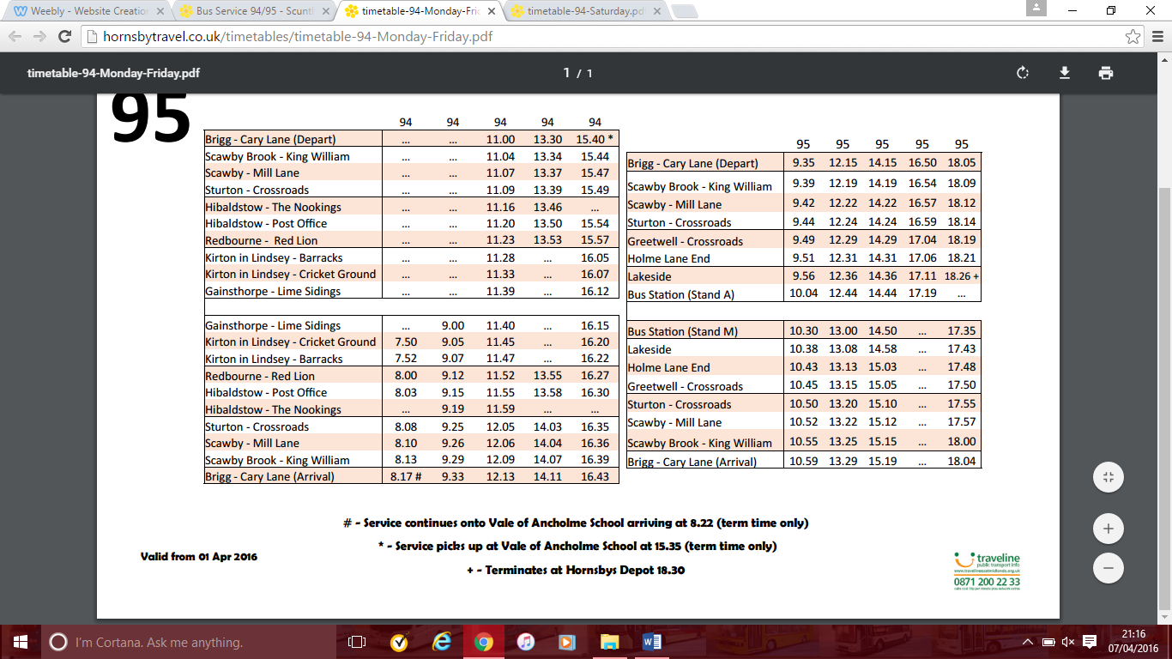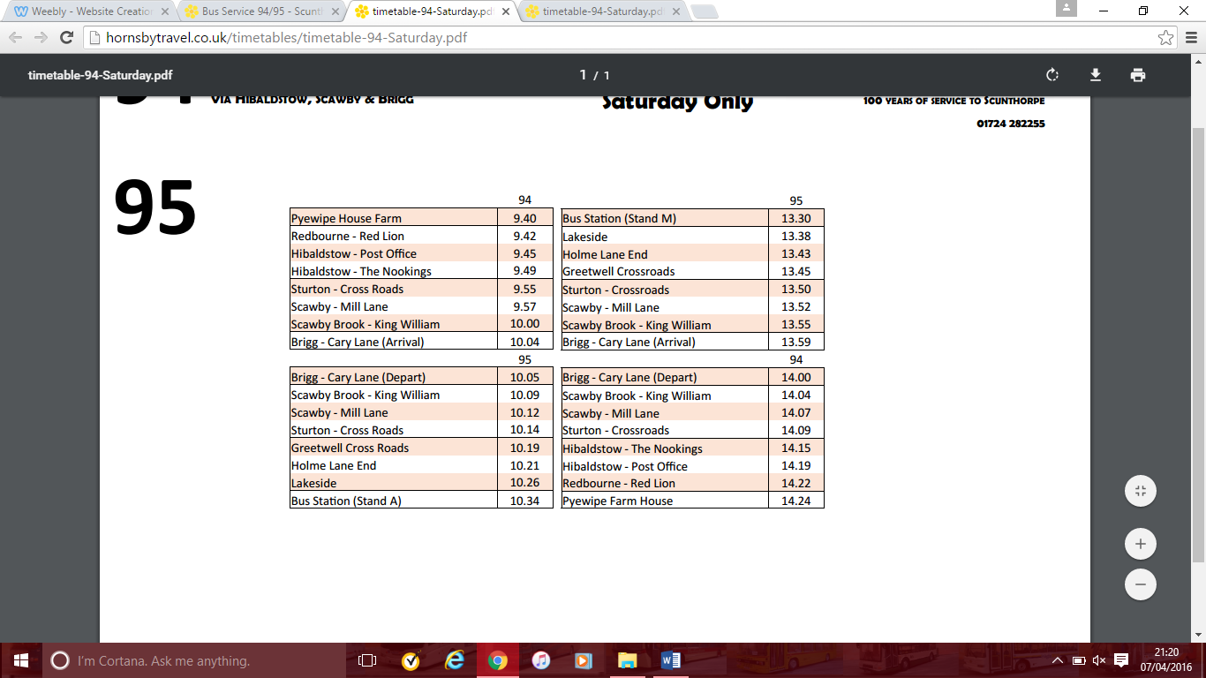

**Saturday**

**Mon – Fri**

# - runs via Vale Academy/Sir John Nelthorpe School

* - picks up at Vale Academy/Sir John Nelthorpe School

**Route 94/95**, Gainsthorpe – Brigg – Scunthorpe

**(Mon – Sat)** **(except bank holidays, not Good Friday)**

CDP Bus & Coach Operator

**www.cdpbusandcoachoperator.weebly.com**

**www.cdpbusandcoachoperator.weebly.com**